1. Sub-Committees under OASIS Open Project
   1. Where do they fit in the OASIS Open Project Organization?

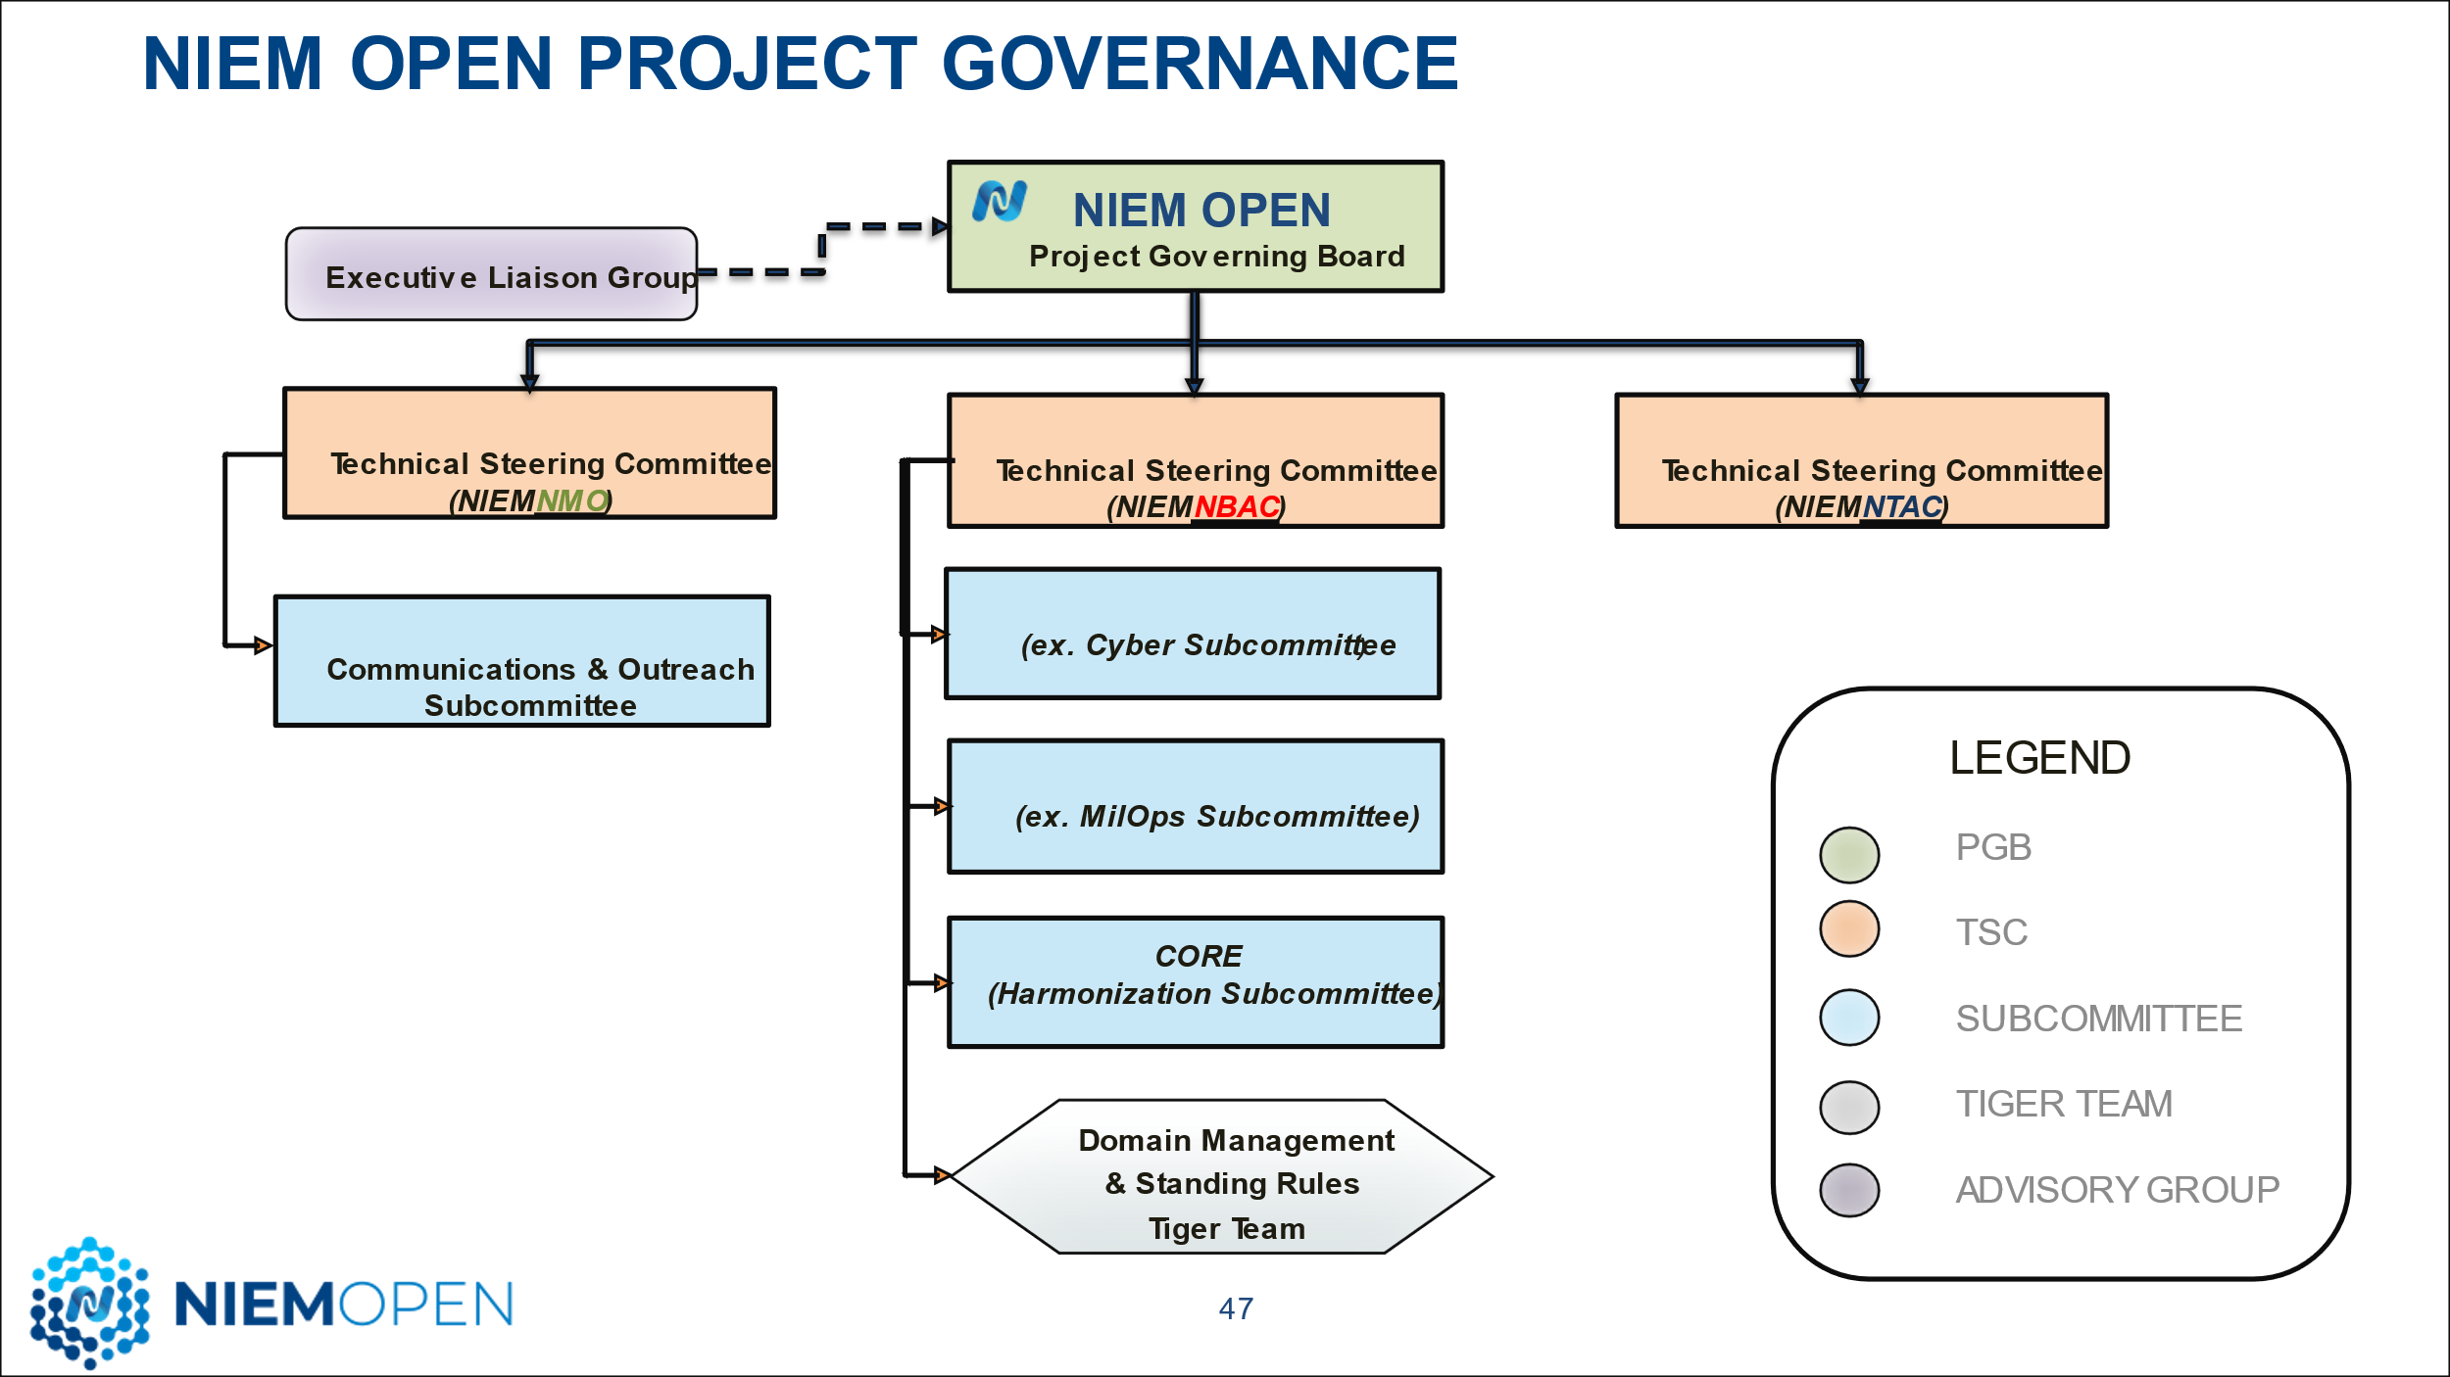

* 1. Formerly called Domains
     1. We use the term domain or domain space when referring to the model/model content
     2. We use the term Sub-Committee to refer to the people/organization managing the model domain content associated with that Sub-Committee (i.e the Biometrics Sub-Committee)
  2. Sub-Committee members need an Entity and Individual Contributor License Agreement (CLA) with OASIS
     1. To complete a CLA you will need a GitHub account (its free); register at the link: <https://github.com/join>
     2. Then proceed to the OASIS Open Project Portal to Register for a CLA
        1. **Entity CLA** <https://community.oasis-open.org/oasis/s/login/?ec=302&startURL=%2Foasis%2Fs%2Fform%3FECLA%3DYes%26id%3Da0S3l00000Axp6pEAB>
        2. **Individual CLA** <https://cla-assistant.io/niemopen/oasis-open-project>
  3. Sub-Committees need to draft a Sub-Committee Governance Document
     1. We have a template for that: <https://github.com/niemopen/nbac-admin/blob/main/sub-committee-documents/(FINAL)%20%20Subcommittee%20Governance%20Template%20%20v2%20Doc%204-5-23.pdf>
     2. Examples are MilOps and Harmonization Sub-Committees
     3. The NBAC TSC can work with you on creating the sub-committee governance doc
     4. Use the template but modify it to fit your needs and circumstances.
  4. The NBAC TSC manages a GitHub Admin Repo where documents, meeting minutes, rosters, etc. can be found: <https://github.com/niemopen/nbac-admin>
  5. Enroll to the **NBAC TASC mailing list**, to subscribe, just send an email to the address: [niemopen-nbactsc+subscribe@lists.oasis-open-projects.org](mailto:niemopen-nbactsc+subscribe@lists.oasis-open-projects.org)
  6. Sub-committees need to appoint a representative to the Harmonization Sub-Committee
     1. Version 6.0, in progress, is a big change to the model and the first version under OASIS
     2. Join the Harmonization Sub-Committee Mailing list: [niemopen-harmonizationsc+subscribe@lists.oasis-open-projects.org](mailto:niemopen-harmonizationsc+subscribe@lists.oasis-open-projects.org)
     3. The POC for the Sub-Committee is Christina Medlin(Georgia Tech Research Institute): [christina.medlin@gtri.gatech.edu](mailto:christina.medlin@gtri.gatech.edu)
     4. The Harmonization process is described in the:
        1. NIEM Open NBAC Governance Doc <https://github.com/niemopen/nbac-admin/blob/main/documents/(FINAL)%20%20NIEMOpen%20NBAC%20Governance%20Doc%20(Rev%201)%20%20v1%204-18-2023%20.pdf>
        2. Harmonization Sub-Committee Governance Doc <https://github.com/niemopen/nbac-admin/blob/main/sub-committee-documents/(FINAL%20)%20Harmonization%20Subcommittee%20Governance%20Doc%20v5%204-18-2023.pdf>
  7. Sub-Committee Meetings – while internal meetings by organizations are appropriate for pre-decisional deliberations, Sub-Committees are encouraged to schedule and hold public meetings at a frequency appropriate to ongoing activities, but at least annually.
  8. Conservatorship Discussion - As Sub-Committees mature, some may reach stasis where there is no requirement to create new model content or exchanges. Additionally, there may be circumstances where a Sub-Committee is suspended, terminated, or otherwise becomes dormant. If a Sub-Committee is inactive, or without a Chair, or dormant for an extended period (6-12 months or as determined by the NBAC TSC), the NBAC TSC may retire the Sub-Committee and act as conservator for the Sub-Committee’s Domain Space model content.

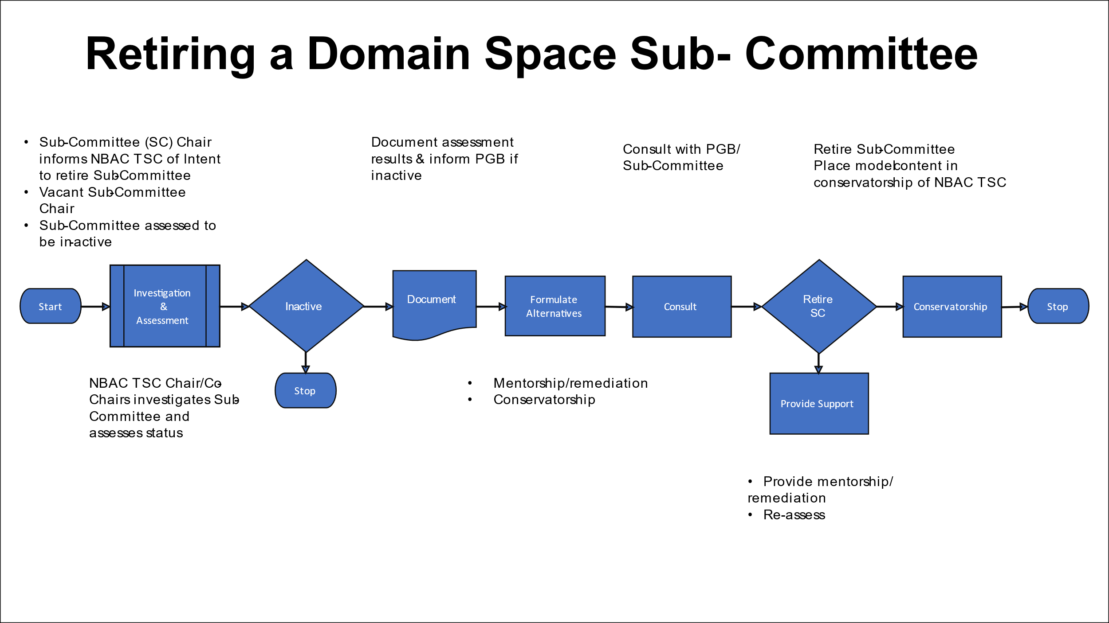

1. Important Reads:
   1. NIEMOpen Charter: <https://github.com/niemopen/oasis-open-project/blob/main/CHARTER.md>
   2. OASIS Open Project Lightweight Rules: <https://www.oasis-open.org/policies-guidelines/open-projects-process/>
   3. NBAC TSC Governance Document (REV 2): https://github.com/niemopen/nbac-admin/blob/main/documents/(APPROVED)%20%20NIEMOpen%20NBAC%20TSC%20Governance%20Doc%20(Rev%202)%20%20v7%20%207-27-2023.pdf